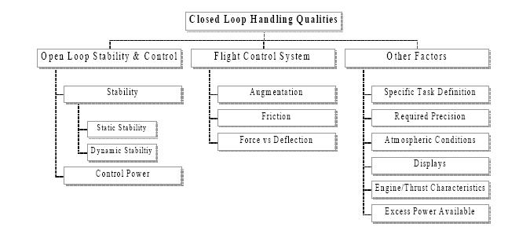

Elements of Closed-Loop Handling Qualities

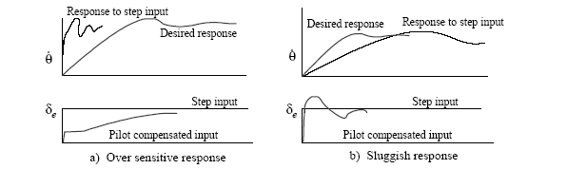

Undesirable step input responses and pilot compensation to achieve desired response
a) Lag compensation, b) lead-lag compensation.

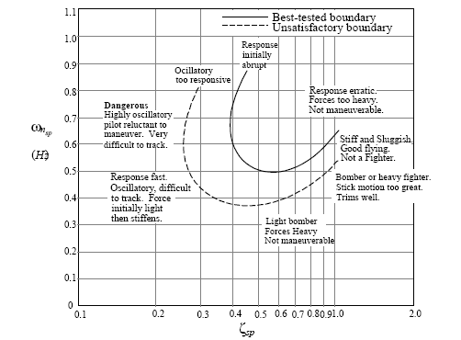

Optimum Short Period Frequency and Damping Based on Pilot Opinion

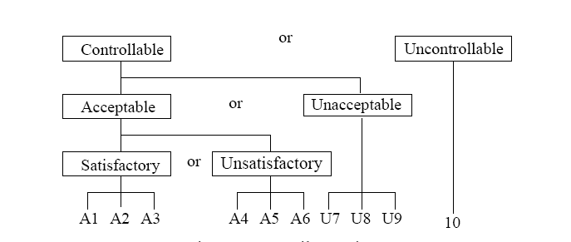

General Pilot Ratings for Handling Qualities

Closed Loop Handling Qualities Test Requirements
1) Explicit mission definition: what the pilot must accomplish. Identify the circumstances and operating conditions.
2) Define mission tasks. Tasks should be repeatable, require sufficient control input frequency to stress the system, and they should be of adequate duration to differentiate transient from steady state responses.
3) Establish desirable and acceptable criteria for task performance. Criteria established should be quantifiable, recordable, and realistic. Desirable criteria specify a satisfactory level of performance. Acceptable criteria specify the level of performance that is marginally adequate.
4) Test should include realistic typical distractions and disturbances.
5) Record task performance relative to the criteria established (comments, video, audio, pipper movement, etc.)
6). Measuring & record pilot workload and compensation.

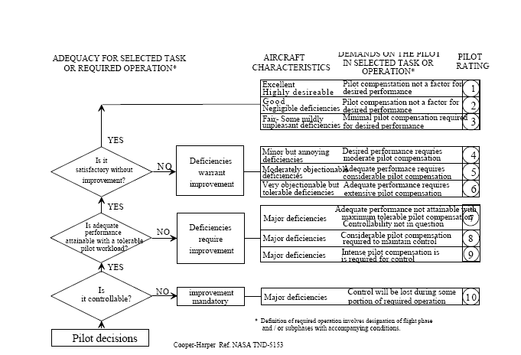

Cooper Harper Workload and Handling Qualities Rating Scale

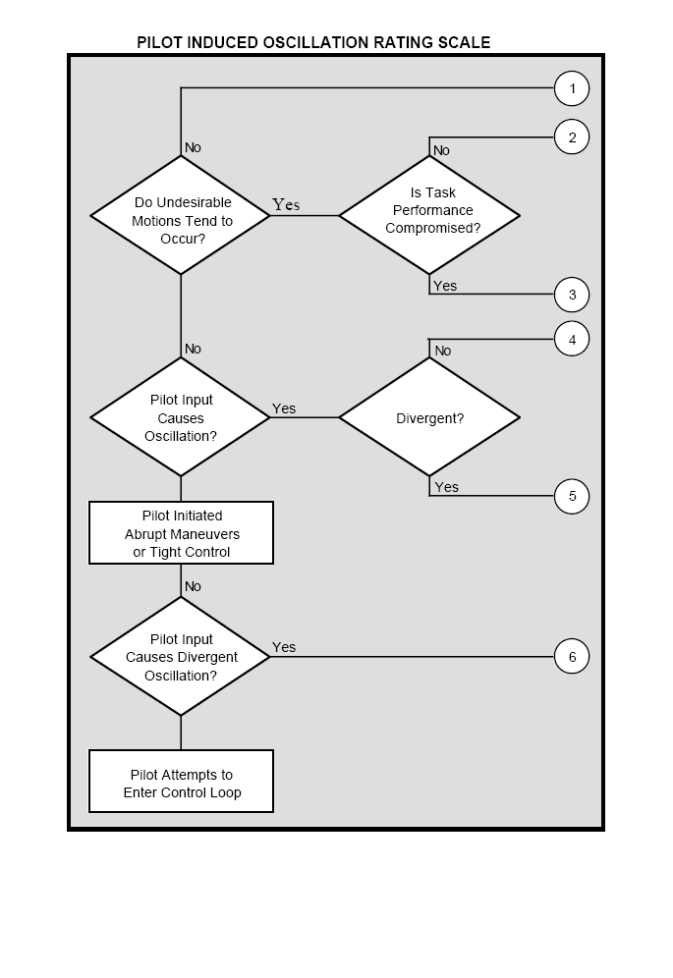
Pilot Induced Oscillations Rating Scale

